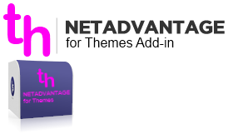

The configuration file should be placed in MyDocuments (as the PGAddin.config).

The source code can be found here: $/NetAdvantage/DEV/XAML/2012.1/Samples/WPF/NetAdvantageForThemes

The NAFTA window can be opened in two ways:

a. Using the button from the **Solution Explorer** window:

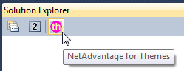

b. Select **View** -> **Other windows** -> **Net Advantage for Themes** from the Visual Studio menu.

Enjoy.

When the window is opened you should see something like this:

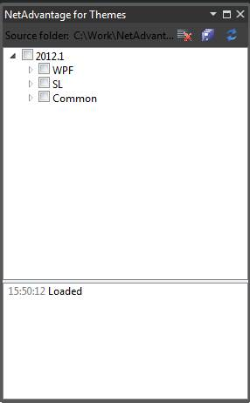

The WPF node expanded:

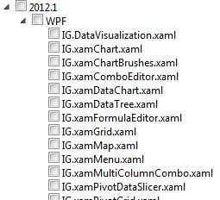

Make your selection (you can select all by checking the checkbox of the version) and click the cid:image008.jpg@01CCC18C.FDA84F70 button. The tool will start downloading the themes from their original location and replace the files in the **Infragistics.Themes** folder of the samples browser. The tool generates a pending change for every theme that is not the same as the original one (selected only).

If you have to add new theme you should do the following:

1. Add the theme file to the corresponding subfolder of the Infragistics.Themes folder (WPF, SL or Common), Add in source controls too.
2. Change the ThemesList.xml (add the path to the Source/Themes/ in TFS)
3. Check-in

**Note:** Keep the ThemesList.xml files (located in every WPF, SL and Common folders) in sync with the themes files inside otherwise the tool will generate errors in the log.